Theo Van der Burgt 300019142

Ben Rizk 300014542

Exercise 1:  
a)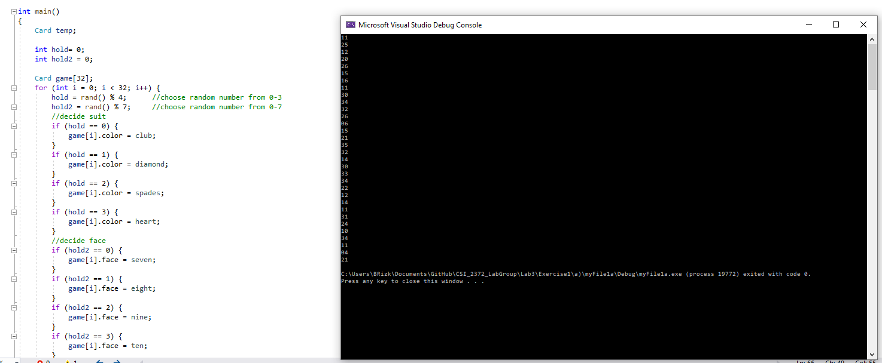

b)

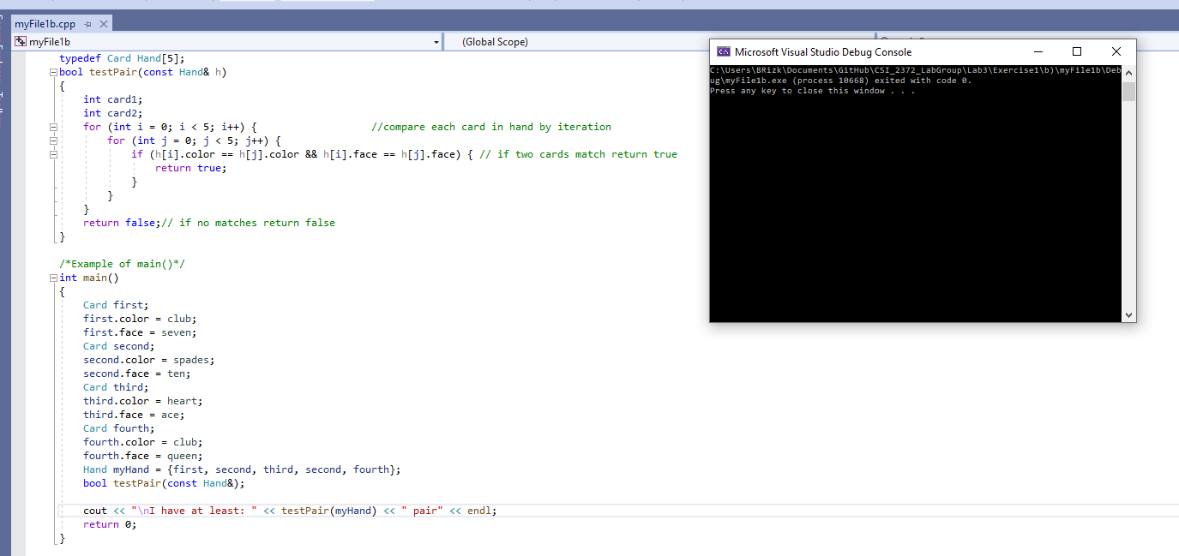

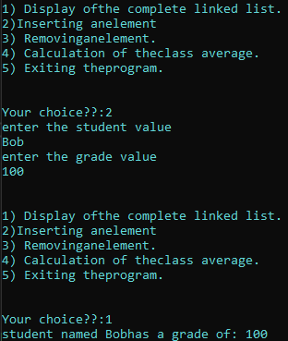

Exercise 2: